**MOTION DETECTION WITH RASPBERRY PI**

-PARTS REQUIRED:

First we need to have the raspberry pi with a raspbian or noobs operating system installed in it.

raspbian is in operating system used for all raspberry pis and noob is an easily installer for raspbian and others.

RASPBERRY PI: ( MICROSED CARD - HDMI CABLE - CASE - OTHER ACCSSORIES)

1- canakit basic raspberry pi starter kit (no-no-no-heat sink pi switch)

2-canakit raspberry pi 3B+ (32gb with noobs- yes- black-heat sink,microsd reader,piswitch)

3-virlos raspberry pi (16gb with noobs-heat sink)

OTHER PARTS:

-breadboard

-motion detection sensor or motion detection algoritm

-push buttons(switches work or cables...The pushbutton is an extra component that allows you to stop the Python script.)

-jumper wires.

-builtin pi camera library

heres the link ive collected all this information from..

https://randomnerdtutorials.com/raspberry-pi-motion-detector-photo-capture/

we need a simple model A raspberry pi for our project.

here are the components of raspberry pi so we have a better understanding regarding that.

(ARMS CPU AND GPU)= ARM is a proccessor based on the archetecture that is reduced instructions set computer.

it has central processing unit and graphics processing unit cpu handles the main ins

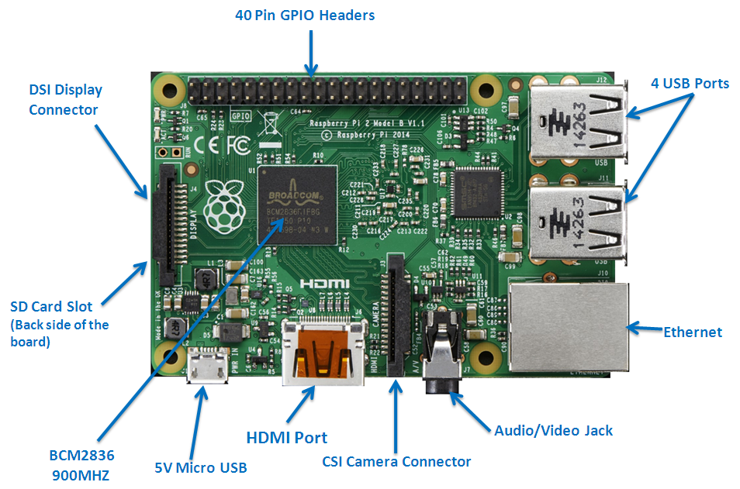

tructions handling that is calculations

and other task whereas gpu will work for the producton of graphics and videos.

GPIO= gneral purpose input output connections points.

RCA CONNECTOR= which allows connections of analogs tvs ans other similiar output devices.

AUDIOOUT= ther is audio out jack for headphones and others but ther is no audio in.

LED= light emitting diods for all your light emitting needs.

USB PORT

HDMI CONNECTOR

POWER= this is a 5 volt micro usb connector in which yuou can easily connect your comaptible power supply.

SD CARD SLOT= this is a sd card alot which is available with a operating system installed in it and it is basically used to

boot the system.(noob operating system).

ETHERNET= this connector is used for wired network access and is only available in model B.

Other things which are needed to be plugged in can be done by using a usb slot.

**HOW RASPBERRY PI LOOKS LIKE**

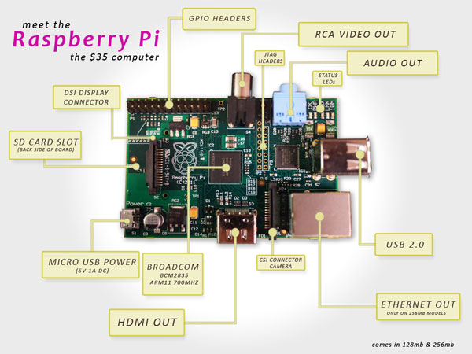

**MODEL B LOOKS AS**

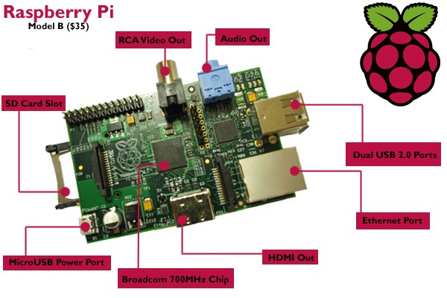

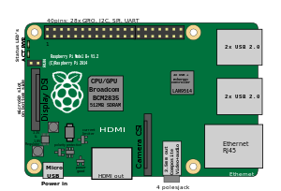



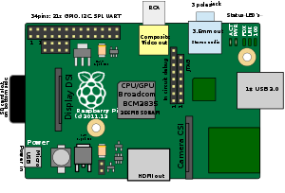

How to install the operating system in raspberry pi by using your pc and sd card

/www.easeus.com/partition-master/how-to-install-raspberry-pi-operating-system-on-sd-card.html